A

TECHNICAL REPORT ON

STUDENTS INDUSTRIAL WORK EXPERIENCE SCHEME (SIWES)

AT

NEOCLOUD TECHNOLOGIES | ICT | COMPUTER TRAINING IN ABUJA.

PRESENTED BY

CHUKWU DANIEL NONSO

BHU/20/04/05/0010.

SUBMITTED TO

THE DEPARTMENT OF COMPUTER SCIENCE,

FACULTY OF SCIENCE AND TECHNOLOGY,

BINGHAM UNIVERSITY KARU, NASSARAWA STATE, NIGERIA.

IN PARTIAL FULFILMENT OF THE REQUIREMENTS FOR THE AWARD OF BACHELOR OF SCIENCE (B.Sc.) DEGREE IN COMPUTER SCIENCE.

NOVEMBER, 2023.

# 

# CERTIFICATION

This is to certify that this report represents the students’ industrial work experience at Neo Cloud Technologies | ICT | Computer Training in Abuja | Suite C30 & 31, M.I.B Plaza, 1st Avenue, Gwarinpa, Nigeria.

I hereby certify that **CHUKWU DANIEL NONSO** with matriculation number **BHU/20/04/05/0010** of the Computer Science department of Bingham University, Karu, Nasarawa state, wrote this report in partial fulfillment of the requirements for the award of Bachelor of Science (B.Sc.).

This report has not been submitted elsewhere.

NAME OF H.O.D NAME OF SIWES CORDINATOR

**DR ADAMU USMAN DR ADELAIYE ISHAYA**

SIGNATURE & DATE SIGNATURE & DATE

____________________ ____________________

NAME OF INSTITUTE BASED SUPERVISOR

……………………………

SIGNATURE & DATE

____________________

# DEDICATION

# This report is dedicated to all the wonderful individuals that contributed to my growth and experience during my period of attachment at the Neo Cloud Technologies Gwarinpa Abuja and that also extends to my parents who played a crucial role in making it all possible and supported me throughout the whole program

# ACKNOWLEDGEMENT

I wish to acknowledge and thank Almighty God and everyone who contributed in one way or the other towards success of my industrial training at Neo Cloud Technologies. I also wish to express my sincere gratitude to the organization for giving me the opportunity to undergo my Industrial Training with them. A huge thanks to Dr. Adelaiye Ishaya, Dr. Ibrahim Yakubu and other staff, I also want to thank the entire staff for their unending efforts especially in teaching me amidst their tight schedules as well as their great supervision throughout the period of my SIWES program. My gratitude also goes to all who contributed towards the success of my Industrial Training and my fellow trainees, also I am grateful to my SIWES coordinator in person of Dr. Adelaiye Ishaya, The H.O.D. of computer science Dr. Adamu Usman, Mrs. Ann Hassan, Dr. Silas Faki, Dr Egene Onu, Dr. Felix, Dr. Gaga, Mr. Godwin Elekwa, Mr. Yusuf Musa, Mr. Jenom Maikori and Mr. Barka Fori, I also appreciate the technologists of the department of computer science Mr. Langthon,, Mr. joseph Aremu, Mrs. Ipole Nancy. Many thanks to the departmental secretary Mrs. Talatu Bowman and other staff of Bingham University.

**CHUKWU DANIEL NONSO**

# ABSTRACT

The Student Industrial Work Experience Scheme established by the Federal Government of Nigeria was aimed at exposing students of higher institutions to acquire industrial skills and practical experiences in their approved courses of study and also prepare students for the Industrial work situation which they are likely to meet after graduation. This technical report is based on the experiences gained during my Seven months of Industrial Training at Neo Cloud Technologies. This report highlights the major based technologies used in the company and projects I was able to gain first-hand experience working on.

Contents

CERTIFICATION 2

DEDICATION 3

ACKNOWLEDGEMENT  4

ABSTRACT 5

CHAPTER ONE 8

1 .0 GENERAL INTRODUCTION TO THE SIWES PROGRAM 9

1.1 NATURE AND SCOPE OF SIWES 9

1.2 AIMS AND OBJECTIVES OF SIWES 9

1.3 BENEFITS OF INDUSTRIAL TRAINING 9

CHAPTER TWO 8

2.2 HISTORY OF NDC 8

2.4 FUNCTIONS OF NATIONAL DEFENCE COLLEGE 9

2.5 VARIOUS DEPARTMENTS IN NDC 9

CHAPTER THREE 10

3.1 SOFTWARE INSTALLATION 13

3.2 INTRODUCTION TO MICROSOFTWORD 13

3.3 INTRODUCTION TO MICROSOFT EXCEL 13

3.2 INTRODUCTION TO MICROSOFT POWER POINT 14

4,0 KNOWLEDGE GAINED DURING SIWES 15

4.0.1LIMITATIONS, CHALLENGES AND ADEQUATE RECOMMENDATION 15

4.0.2 LIMITATIONS OF THE TRAINING 15

4.0.3 CONCLUSION 16

4.0.4 RECOMMENDATIONS 16

4.0.5 SUGGESTIONS TO FUTURE SIWES STUDENTS 17

4.0.6 REFERENCES 18

# CHAPTER ONE

## 1 .0 GENERAL INTRODUCTION TO THE SIWES PROGRAM

## Prior to the inception of the Student Industrial Work Experience Scheme (SIWES), a growing concern prevailed among industrialists regarding the readiness of graduates from higher education institutions. They believed that these graduates lacked the necessary practical background essential for employment in various industries. Consequently, employers held the view that the theoretical education provided by higher institutions did not align with the practical requirements of the labour market.

## In response to this pressing issue, the Industrial Training Fund (ITF) took a proactive step by establishing the Student Industrial Work Experience Scheme (SIWES) in 1973. SIWES emerged as a mandatory Skills Training Programme aimed at addressing the deficiency in practical skills among Nigerian graduates from tertiary institutions. Its primary objective was to bridge the gap between theoretical knowledge and the practical competencies necessary for successful employment within the industrial sector.

## 1.1 NATURE AND SCOPE OF SIWES

The duration of a student's attachment during SIWES varies depending on the specific program. Typically, the minimum duration for SIWES should be six months or twenty-four weeks. However, for students in the fields of engineering and technology at the university level, the attachment period is extended to twenty-four weeks. Throughout the course of the program, students are expected to accumulate a total attachment duration of at least 240 hours on a full-time basis, which may occur during either term-time or extended vacation periods.

In addition to the attachment period, there are induction sessions conducted by teaching departments. These sessions serve to impart essential concepts related to key skills, workplace safety, professional expectations, legalities, and ethics. These sessions are crucial in preparing students for their SIWES experience, equipping them with the necessary knowledge and skills for learning, employment, and life.

1.2 AIMS AND OBJECTIVES OF SIWES

Participation in SIWES has become a mandatory requirement for obtaining Diploma and Degree certificates in specific fields at the majority of higher education institutions in the country, in strict accordance with the government's educational policy.

It aims to:

1. Equip students with the necessary skills and acumen to navigate the demands of the industrial workplace post-graduation.
2. Familiarize students with specialized work methods and advanced equipment not typically available within their academic institutions.
3. Facilitate a smoother transition from academic life to the professional world, enhancing their network for future job opportunities.
4. Bridge the gap between theoretical knowledge and practical application by allowing students to apply their learning in real-world scenarios.
5. Foster and strengthen collaboration with employers throughout the educational journey, ultimately preparing students for successful employment upon graduation.

## 1.3 BENEFITS OF INDUSTRIAL TRAINING

Experts recognize that industrial experience is essential for effective job preparation. This is because experience significantly enhances the productivity of both recent graduates and newcomers entering the workforce. Early exposure to the industry's values and skills is crucial. Without the right skills and experiences, young graduates are not adequately equipped with the necessary work-related norms and behaviours, which are vital for success in the workplace.

Today, the landscape of many jobs is being reshaped by Information and Communication Technology (ICT), resulting in shifts in the knowledge and skills required of workers. Consequently, our students need to attain a new level of competency that goes beyond what traditional educational facilities can provide. This necessitates a collaborative effort between educational institutions and the industrial sector.

One of the primary advantages for students who actively participate in industrial training lies in the skills and competencies they acquire. These skills, often referred to as Relevant Production Skills (RPSs), become lifelong assets. They are internalized during training and prove invaluable when students apply them to perform their jobs or functions. Additionally, numerous other benefits accrue to students who engage in industrial training.

Furthermore, industrial training provides a conducive environment for students to develop and enhance personal attributes such as critical thinking, creativity, initiative, resourcefulness, leadership, time management, presentation skills, and interpersonal skills, among others. These attributes are invaluable assets that can significantly enrich a student's overall skill set and readiness for the professional world.

# CHAPTER TWO

1.0 Description of the Establishment of Attachment

Neo Cloud Technologies is a multi-product IT firm that provides creative and technology services across various sectors.

In the fall of 2017, Neo Cloud recognized a need in the industry for an innovative IT consulting firm that prioritized the needs of their clients. They’ve since then expanded to a team of over 25 employees, all of whom are dedicated to implementing full-stack solutions for Digital Transformation.

Neo Cloud also largely focuses on the education aspect of tech, training students all across the globe that are looking to get into tech. The company has trained over 2000 Nigerians in areas such as Cloud computing, Web development, Backend Development, Graphics Design, Data Analysis and so on.

Neo Cloud Technologies has over 20 certified instructors that are highly skilled at training people and taking their various skill levels from beginner to expert.

1.1 Why We Exist

We exist as an IT company to forge innovative solutions that will change the narrative of the information technology ecosystem through the creation of bespoke solutions that meet customers' needs.

1.2 Mission

To constantly exceed customer expectations by understanding their business needs and providing complete IT solutions.

1.3 Big-Picture Vision

Neo Cloud Technologies belongs to a specialised niche or business, yet it is far from alone. With the appropriate innovation, we will be able to give something unique to our customers, making their brand stand out in the market and making it extremely easy for them to grow their income.

Talented, forward-thinking individuals want to work with forward-thinking organizations. Because the firm has a history of innovation, Neo Cloud Technologies is designed to attract anyone who is going to build the next great thing. We foster and develop innovators because they want to be challenged and pushed to innovate on a regular basis.

1.4 Brand Story

Neo Cloud Technologies was founded in November 2017, with the mission of constantly exceeding customer expectations by understanding their business needs and providing complete solutions. The company has always positioned itself as a provider of bespoke solutions to client's needs in the technology space.

The brand message "The Hybrid Experience" refers to a complete new technology experience created by combining clients' obsolete technology with our emerging technology and bespoke solutions to meet their everyday needs as an organization or individual. Regardless of their location, we have them covered because we are "The Hybrid Experience."

1.5 Services

The company provides the critical combination of infrastructure, service, training, and management required to unleash the power of ICT and Trans-National Education (TNE), leading to globally recognized degree and certifications for human capacity development and economic empowerment

The company provides educational facilities and learning guideline and also gets contracted by both governmental and non-governmental organizations to help build software’s and network for their organization.

Some services provided includes:

**IT Support Services**

We provide a wide range of IT Services, including Onsite and Remote Support, IT Consultancy, System Maintenance, Software Installation, Cybersecurity Services, Networking Support, Web and Application Development, Virus Protection, Backup and Recovery, Camera Setups and More

**Software Project Rescue**

Clients who are experiencing difficulties with ongoing software projects or who need maintenance for existing applications can turn to Neo Cloud Technologies for assistance

**Software Development**

Neo Cloud Technologies has reputable proficiency in the development of Custom Software Solutions, Portals, e-Commerce Applications, Business Application and Automation Software

**IT Product Sales**

With a dedicated design desk team created as part of our Managed Service Program, our Hardware and Software Design Specialists know how to maximize vendor programs to ensure that our clients maximize their technology expenditures

**Cyber Security Services**

At Neo Cloud, we offer top-tier Cybersecurity Solutions that protect your Digital Assets, thereby ensuring business continuity and boosting client’s confidence. We identify potential cyber hazards to your organization and implement stringent preventative measures

**Cloud Solutions**

Your company will be able to adapt more quickly to shifting market dynamics if you take advantage of the complete Cloud Solutions that we provide here at Neo Cloud. These Solutions improve flexibility, cut expenses, and increase operational efficiency.

**Data Science Services**

We specialize in Artificial Intelligence, Data Science, and Big Data Analytics. Neo Cloud helps its customers increase productivity, return on investment, and strategic decision-making by empowering them to create data-driven companies. When you work with us, you will have access to industry-leading Analytics Measures for your business

**Corporate Branding Services**

Create an identity for your business or modernize an outdated appearance to make it more visually appealing for your brand. We create unique, ready-to-go designs for your company, ranging from Logo, Website Design, Packaging to Custom illustrations

**Digital Marketing Services**

You can no longer expect to win clients over by depending solely on your traditional advertising strategies given the growing number of businesses that are devoting more time and resources to Online Marketing. Internet marketing services that are focused on providing value can help you boost your sales volume while also laying a solid basis for your business's digital presence

**Social Media Services**

The Neo Cloud Social Media Brand Management Solution integrates Social Media Management and Social Media Advertising to help Businesses create a strong and consistent online presence that draws in new customers, keeps existing ones engaged, and increases sales and profits

**SEO Services**

To get your website to the top of Google's search results page, you need a collaborator who is well-versed in Search Engine Optimization (SEO). To assist you climb the search engine rankings, we provide top-tier Search Engine Optimization (SEO) Services

**IT Staffing Services**

We provide our clients with a comprehensive selection of IT Staffing options, which includes Contract Workers, Contract-to-Hire Placements, Direct Hiring, and a Managed Service

1.6 Support Team



**Anthony Ojei Sharon Omolegbe Jerry Brown**

Head - Digital Marketing Manager Head - Visual Communications



**Brown George Godstime Edet**

Head – Training & Research Head – Software Engineering

1.7 Company’s Operations

Neo Cloud Technology plays a very vital role in the community with standard educational systems, solution to all kinds of problems, and a great facility for all. I actually chose this company because they had great facilities for self-development, with great people there and they didn’t seem too stiff as most government agencies are.

The company's daily operations involve a dual focus on student training and project development for external organizations, with working hours from 8 am to 4 pm. The training for students is scheduled on Mondays, Wednesdays, and Fridays, while Tuesdays and Thursdays are dedicated to the professional development of our employees. At our company, we highly encourage and sponsor our employees to enhance their knowledge and skills, fostering continuous growth and expanding their certifications.

Our training program encompasses a wide array of courses, each conducted in separate classrooms by various instructors, who may deliver the lessons either virtually or in person at our organization. This approach allows us to offer a diverse range of educational opportunities, ensuring that our students receive comprehensive training tailored to their specific needs.

Additionally, during the summer months, we host a special boot camp for children aged 6 to 18. This program aims to enrich their understanding of technology and equip them with valuable computer skills. Participants engage in various courses, including web development, graphic designing, excel usage, typing lessons, coding, 3D animation and design, as well as essential computer skills like Microsoft Word and similar applications. Our goal is to inspire and empower the next generation of tech-savvy individuals, setting them on a path to success in the digital age.

1.8 Company’s Policies

The company has established a set of rules and policies to govern its operations. These policies ensure a smooth and ethical working environment for all staff members.

1. **Confidentiality Policy:**

* Protect sensitive company information and client data.
* Do not disclose proprietary information to external parties without proper authorization.
* Diversity and Inclusion Policy:

1. **Promote diversity and inclusivity in all aspects of the workplace.**

* Respect and value differences among colleagues and clients.

1. **Health and Safety Policy:**

* Prioritize the health and safety of all employees.
* Follow safety guidelines and report any hazards or incidents promptly.

1. **Professional Development Policy:**

* Continuously improve your skills and knowledge.
* Utilize available resources for self-improvement and career growth.

1. **Anti-Harassment Policy:**

* Create a respectful and harassment-free workplace.
* Report any instances of harassment, discrimination, or misconduct immediately.

1. **Social Media and Online Conduct Policy:**

* Maintain a professional online presence.
* Do not engage in any behavior online that reflects negatively on the company.

1. **Environmental Sustainability Policy:**

* Contribute to environmental conservation efforts.
* Reduce waste and promote eco-friendly practices in the workplace.

1. **Expense Reimbursement Policy:**

* Adhere to company guidelines for expense reporting and reimbursement.
* Ensure all expenses are legitimate and properly documented.

1. **Code of Ethics and Integrity:**

* Uphold high ethical standards in all business dealings.
* Avoid conflicts of interest and act honestly and transparently.

1. **Data Security and Privacy Policy:**

* Safeguard sensitive data and personal information.
* Comply with data protection regulations and company data security protocols.

1. **Dress Code and Appearance Policy:**

* Adhere to the company's dress code guidelines.
* Present a professional and neat appearance at all times.

1. **Customer Satisfaction Policy:**

* Prioritize customer satisfaction in all interactions.
* Go the extra mile to meet customer needs and expectations.

These policies reflects the company’s commitment to professionalism, ethics, and the well-being of our employees and clients. Violations of these policies may result in appropriate consequences, as the company places a strong emphasis on upholding its rules and standards.

# CHAPTER THREE

1.0 Industrial Work

During my 7 months of Internship experience at Neo Cloud Technologies, I was able to learn a lot of new things and gain a first-hand experience on how a real world tech job would be like.

I worked mainly with the cross platform mobile app building tech stack called Flutter as that was the technology I was required to work with mainly at the company. But even though I worked with Flutter mainly, I was able to also cut across an array of equally interesting technologies and ended up building some simple applications, such as:

* My Portfolio Website
* A Note Taking Application
* A School Management System Mobile App (Still in development…)

1.1 Portfolio Website

I was able to rebuild my portfolio website using Next.JS, Framer Motion and Tailwind CSS. I got the chance to learn all these technologies during my time at the company. Some of the features I was able to implement in this portfolio are as follows

* Smooth navbar selection (using framer motion)
* Page Reveal (using framer motion)
* Light and Dark Mode (using TailwindCSS)
* Messaging (using Twillio)
* State Management (using Zustland)

I got to deploy the application on vercel and got a free domain as you can tell from the domain name with the .vercel.app extention

**Link:** <https://chukwudaniel.vercel.app/>

**Old Portfolio Link:** <https://chukwudaniel.netlify.app/>

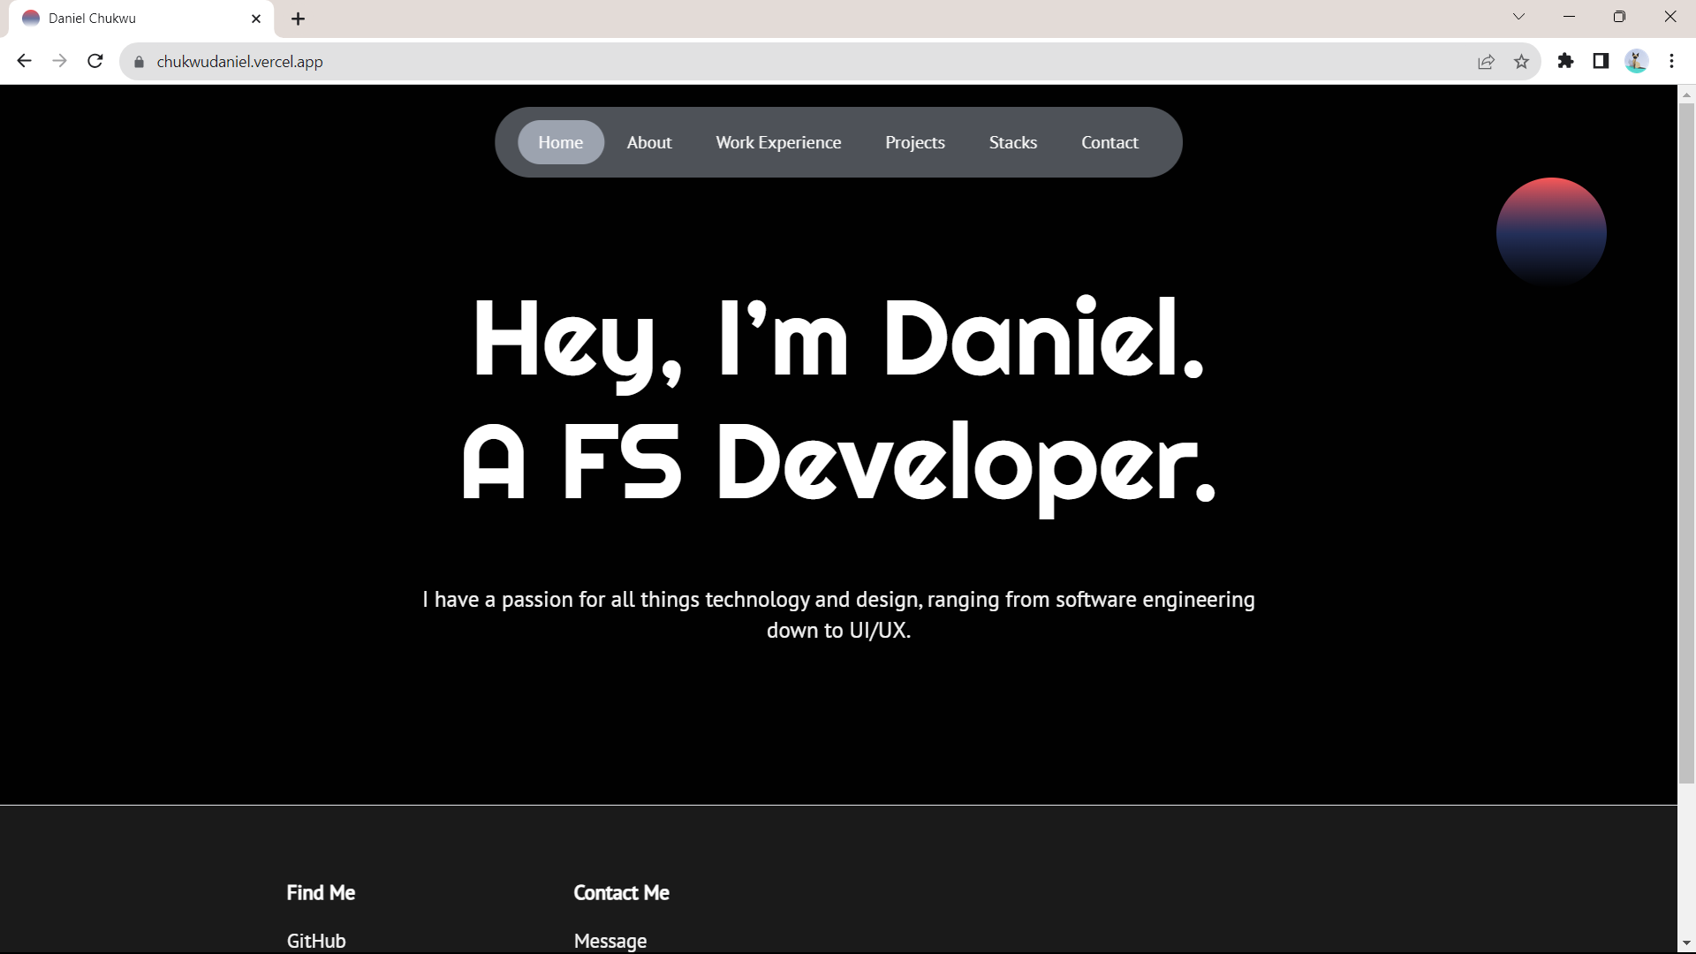

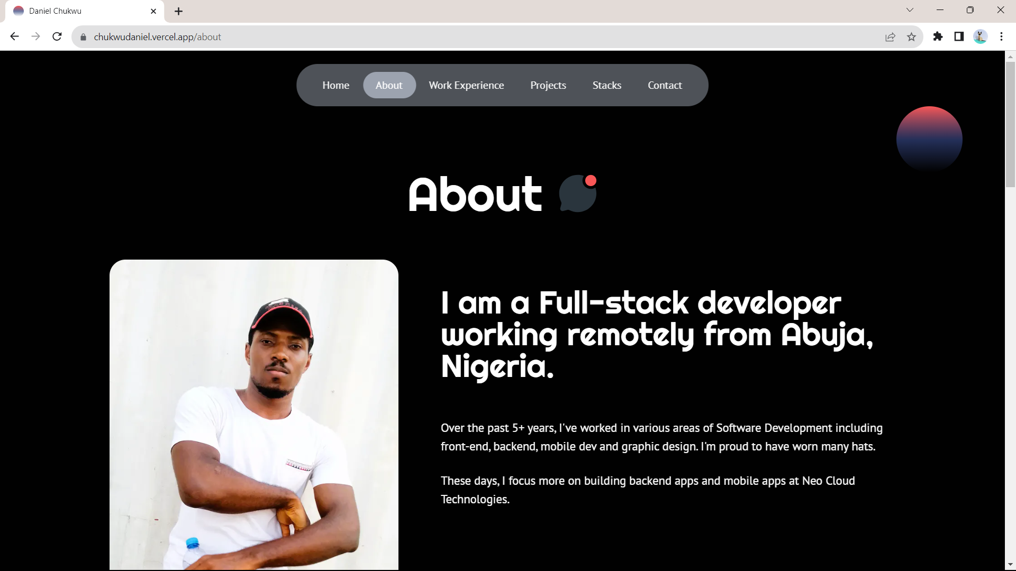

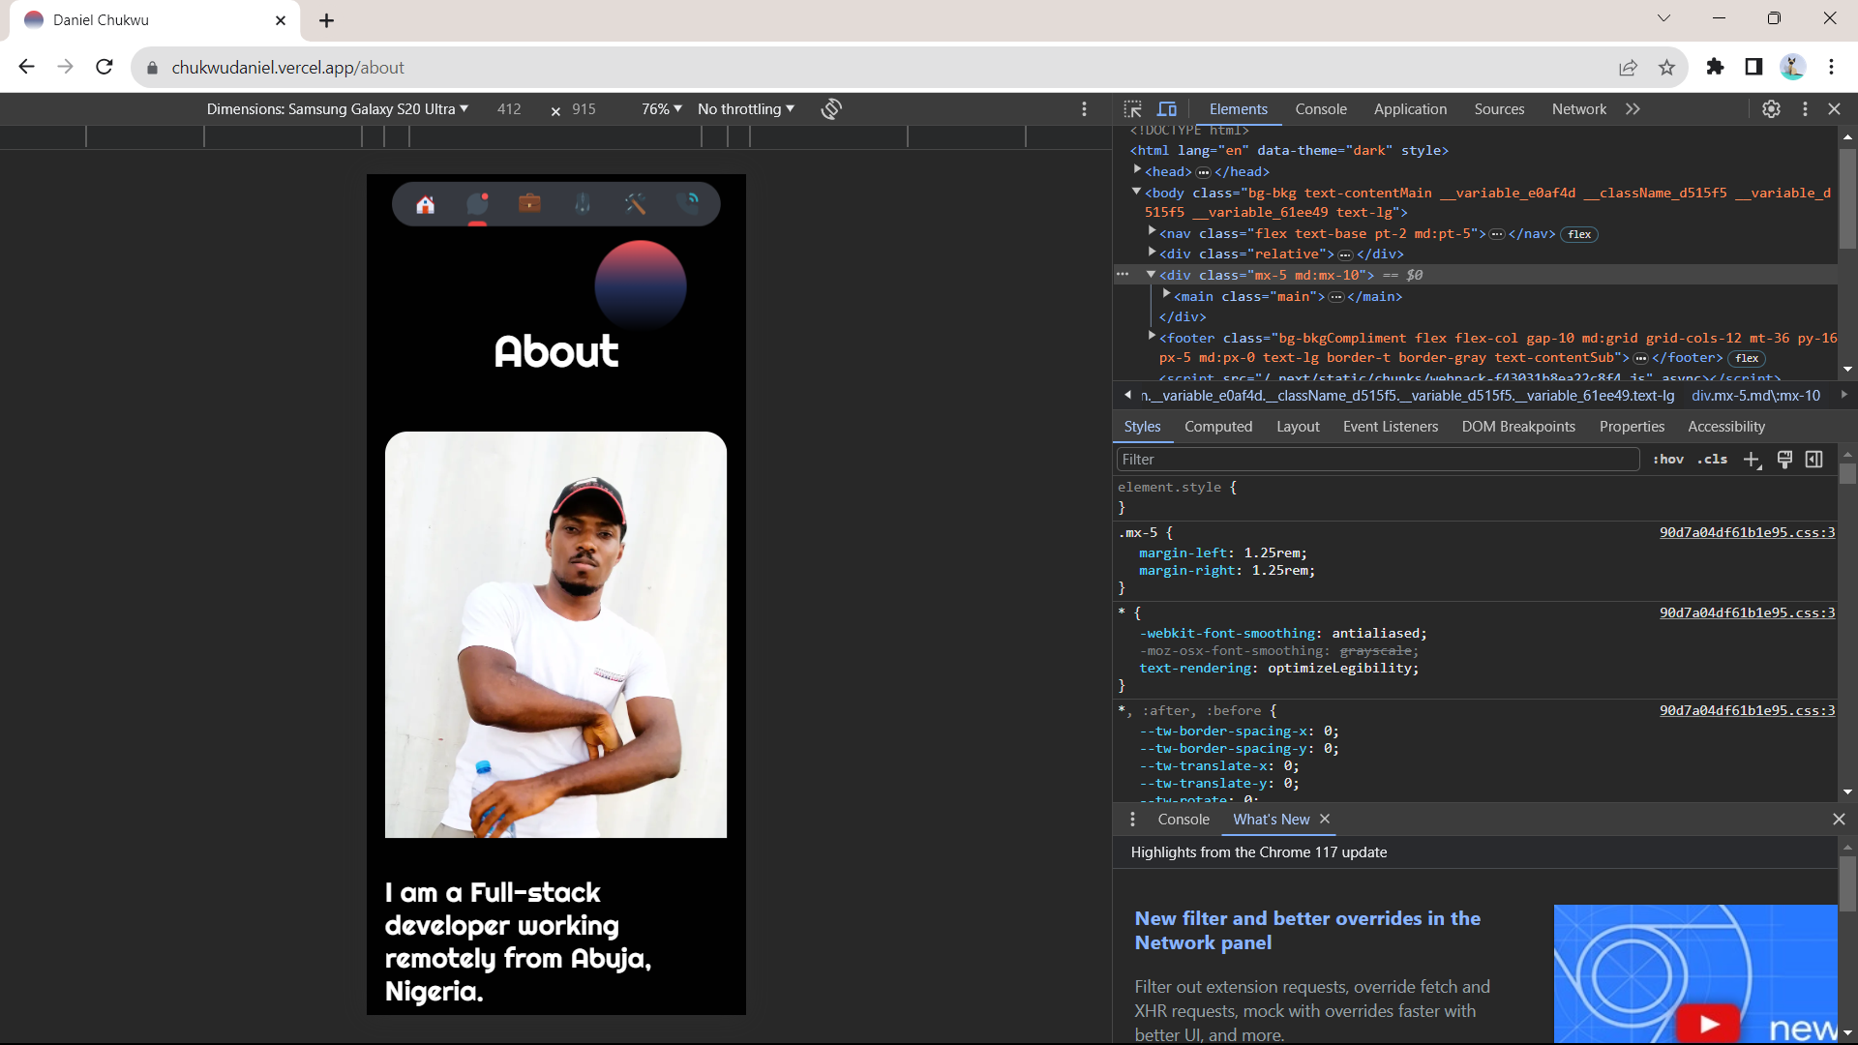

1.2 Take Note (a note taking application)

I always wanted to create an application that had a different feel to note taking, I was able to achieve this during the SIWES program. Unlike the portfolio website, this note taking application required a backend and a database to store the notes taken. The application was built using Typescript and Angular JS for the frontend and Spring Boot with Java for the backend, while I used PostgreSQL for the database.

This application took a month to complete and it had the following features.

* Authentication
* Notebook
* Note Taking (in NoteBooks)
* And CRUD operations for Notebooks and the notes in those notebooks

I deployed both the frontend and backend of this application on render.com

**Link:** <https://takenote-h0yd.onrender.com/>

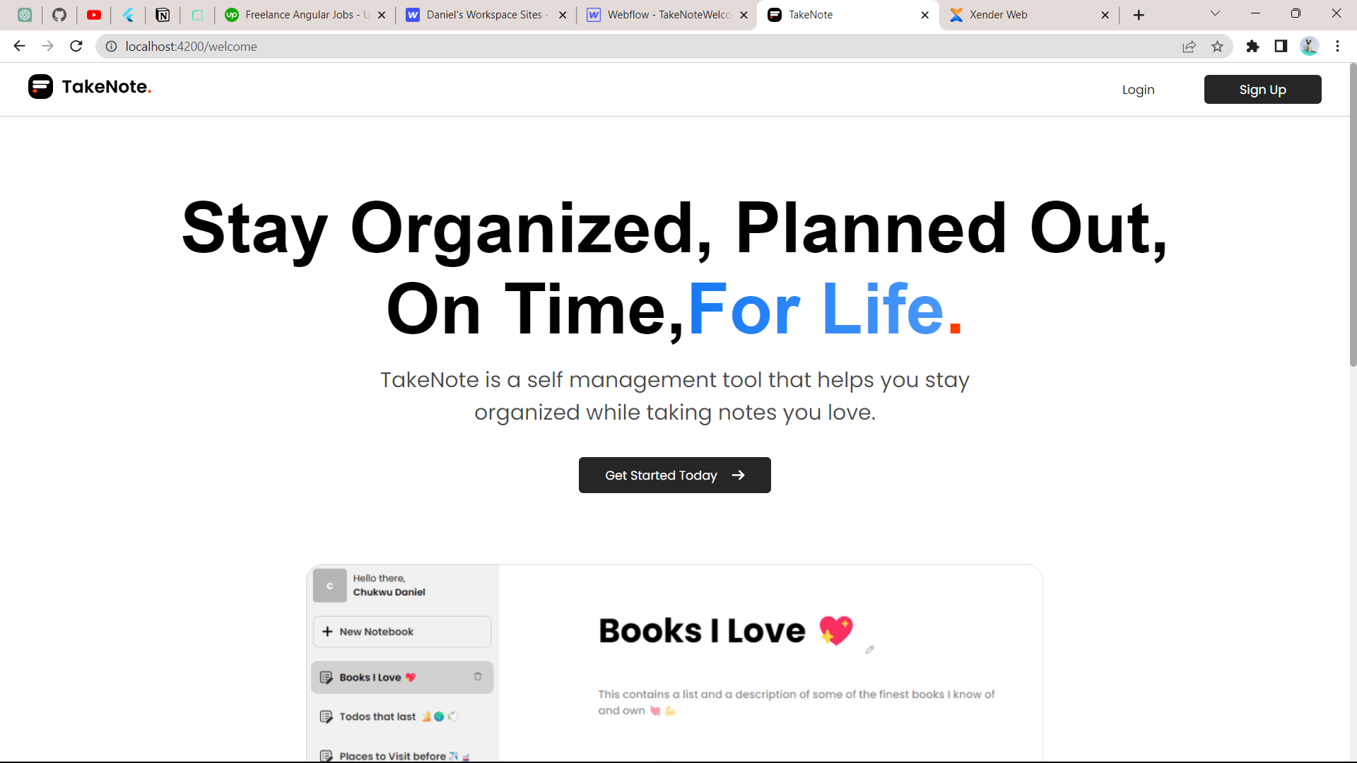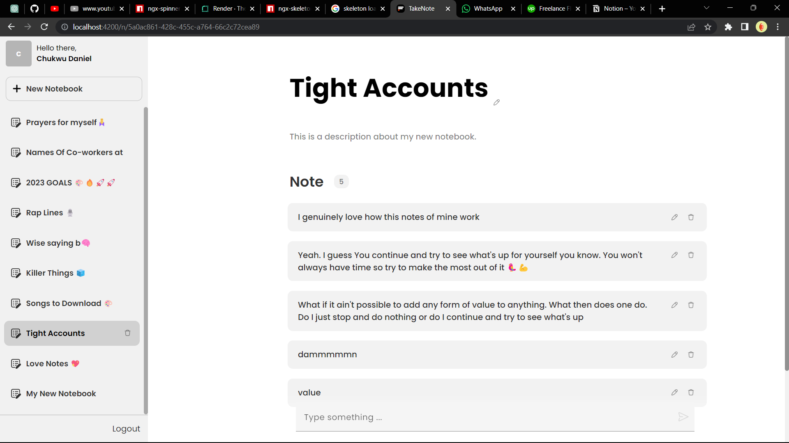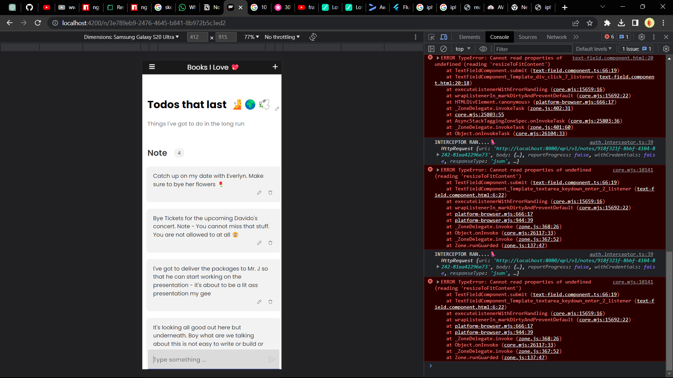

1.3 Neo Cloud Technologies Mobile Application

The first month I resumed at Neo Cloud Technologies I was tasked with building out a mobile application that helps the organization manage their Instructors and Students. I started building this application using Flutter, Node.JS, Typescript, GraphQL and MongoDB. For over 7 months I’ve been working on this application and I’m still yet to finish.

This application has a lot of features some of which are:

* Authentication & Authorization
* Roles
* Search
* User Profile
* Settings
* Faculties
* Classes
* Class Modules
* Class Schedules
* Class Instances
* Classwork’s
* Class Modules housing multiple Class Schedules
* Light and Dark Mode
* Uploading of Images
* Clean Architecture
* State Management Using Bloc
* Followed the TDD Approach to Software Development

**GitHub Link:** <https://github.com/danielchukwu/neocloud-learning-admin-mobile>

**Figma Design**

**Db Design**

**Screenshots**

